Design Competition for Rehabilitation of the Jamsu Bridge
IABSE Young Engineers Colloquium in East Asia

Introduction
This competition is to explore innovative ideas toward the rehabilitation of the Jamsu Bridge. The rehabilitation project comprises the pedestrianization of the Jamsu Bridge and the construction of a new bridge connecting the Jamsu Bridge and nearby waterfront structures of Sebitseom floating Island. This design competition is in connection with the international design competition for the pedestrianization of the Jamsu Bridge recently held by the Seoul Metropolitan Government to revitalize the waterfront space along the Han River.

Construction Site
Figure 1 shows the construction site for the Jamsu Bridge and nearby waterfront structures of Sebitseom floating Island. The Jamsu Bridge is located on the central axis connecting the north and south of Seoul across the Han River. On the map, the Jamsu Bridge and the Banpo Bridge are in the same location. That is, the Jamsu Bridge has the Banpo Bridge on top. In 1976, the Jamsu Bridge was built first by allowing it to be submerged during heavy rain. In 1982, the Banpo Bridge was built on top of the Jamsu Bridge, making it a two-deck bridge. The Jamsu Bridge is 795 m long and 18 m wide, and the piers are spaced 15 m apart. Detailed information on the design location is available by scanning the QR code in Figure 1.

Design Scope
As for the design scope, participants freely select one of the following options:
- Pedestrianization of the Jamsu Bridge
The entire or partial section of the Jamsu Bridge can be freely selected for remodeling or rebuilding of the existing Bridge to introduce the concept of pedestrianization.
- Construction of a bridge connecting the Jamsu Bridge and Sebitseom floating Island
The location of the connecting bridge can be freely selected.

Design Considerations

- Type of bridge: Footbridge (for pedestrians and bicycles)
- Live load: 3.5 kN/m²
- Basic design wind speed: 30.0 m/s (return period: 100 years)
- Construction material: no restriction
- Strength of material: no restriction
- Ground condition: good
- Water depth: 10 m
- Other design requirements for the proposed structure are to be assumed by the participants as engineering judgement based on considering the information provided about the construction site.

Evaluation Items
The following items will be considered for evaluation.
- Creativity
- Rationality on structural system
- Harmony with coexisting structures
- Aesthetics (structural art)
- Waterfront landscape
- Constructability
- Flood Resilience (ref: https://www.youtube.com/watch?v=WKoz3BmZwEg)
- Impact on the environment

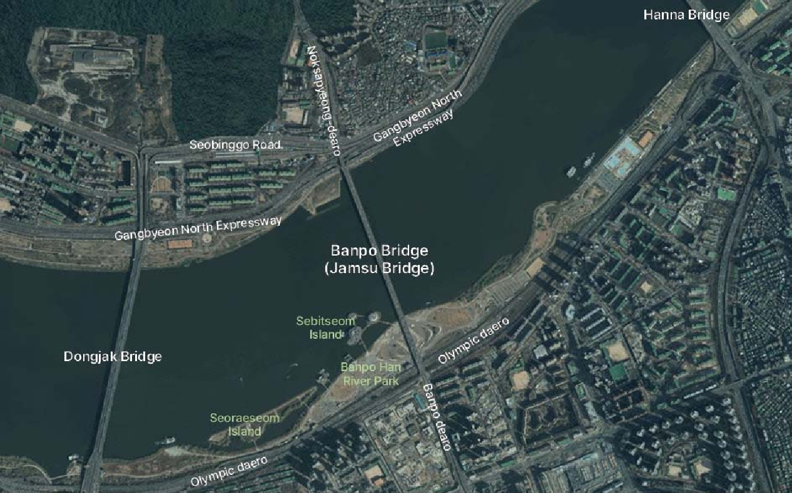

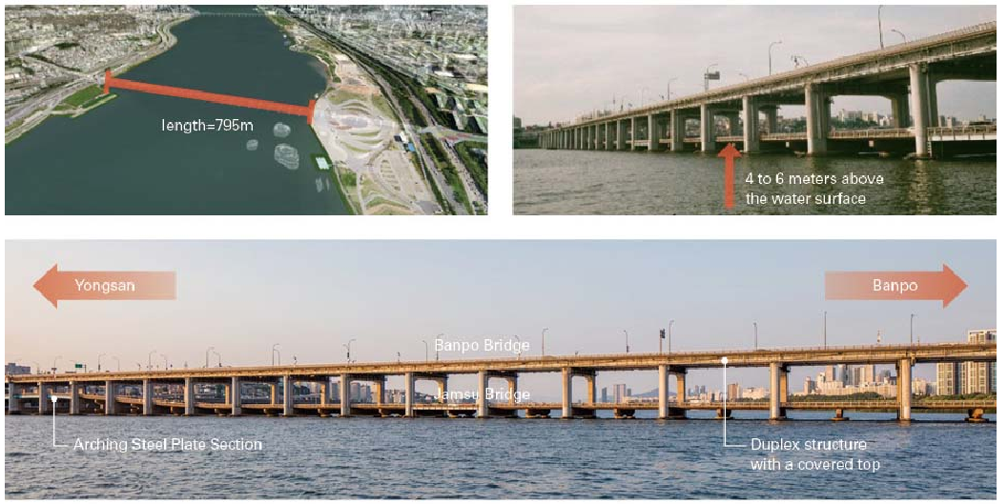

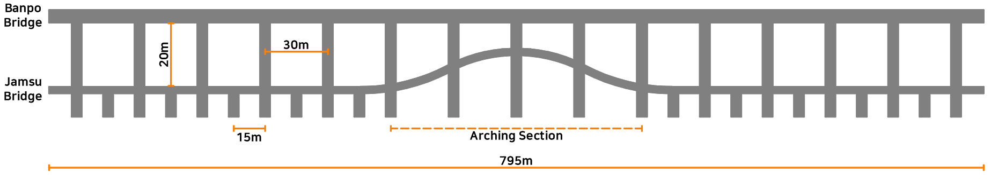
Figure 1 Construction site for the Jamsu Bridge and nearby waterfront structures

Submission
Participants should submit a two-page paper which introduces the design concept. Also, the paper is encouraged to mention the evaluation items.

Deadline of Submission
December 22nd 2023.

Mounting Poster
The poster area will be located in the session room. All posters are A1 size (594 mm wide x 841 mm high). Please make sure to mount your poster on the poster board with the number corresponding to the number assigned to your poster. The poster number will be sent by email.

Presentation
Participants are required to make a 10-minute presentation in Presentations for Design Competition on January 19th, 2024. Please bring a PPT or PDF data for the presentation.

Announcement of the Result
Prizes will be awarded to outstanding designs in Closing Ceremony with award presentation on January 19th, 2024.

Contacts
Dr. Namhee-Kim Hong, Korean Institute of Bridge and Structural Engineers, Korea (Chair of Design Competition)
Email: namheek@snu.ac.kr

