Title of the paper or project report and design
Full name, IABSE Corporation, Seoul, Korea/ Full name, University of IABSE, Seoul, Korea
E-mail address: xxx@xxxx.xxx

Abstract
Abstract of the research and technical report is described with about 150 words.
Keywords: About five keywords are required such as A; B; C; D; E.

Introduction
Two-page abstract and one-page CV should be written using this template. It should be submitted as PDF file to kibse@kibse.or.kr.

Chapter 2

Section 2.1
Chapters, sections, figures, tables and references should be written in this way.

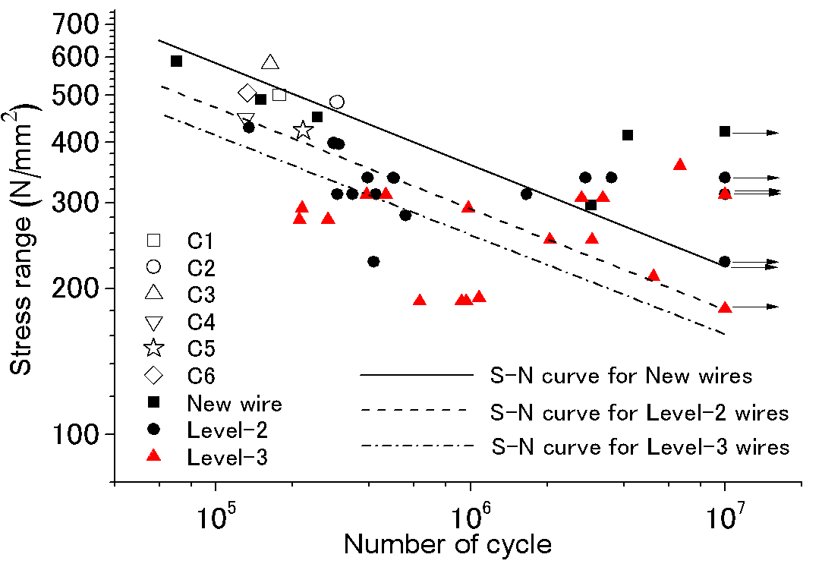

Figure 1. Fatigue data of corroded wires
Table 1. Cross-sectional area

No. | Net  Area  An(mm²) | Maximum  Stress  (MPa) | Minimum  Stress  (MPa) | Stress  Range  (MPa)
C-1 | 18.718 | 1056.7 | 556.2 | 500.5
C-2 | 19.342 | 1022.6 | 538.2 | 484.4
C-3 | 17.928 | 1161.5 | 580.6 | 580.9

Chapter 3

Section 3.1
This is Section 3.1, Chapter 3.

Section 3.2
This is Section 3.2, Chapter 3.

Chapter 4

Section 4.1
This is Section 4.1, Chapter 4.

Section 4.2
This is Section 4.2, Chapter 4.

Conclusions
Conclusions are required
- References
- Chen, E. P. and Hashi, K. Mechanical Properties and Remaining Strength of Corroded Bridge Wires. SEI, Journal of IABSE. 2004; 14(3): 50-54.
- Chen, E. P. and Hashi, K. Hydrogen Embrittlement and Corrosion Fatigue of Corroded Bridge Wires. Journal of Constructional Steel Research, Elsevier. 2009; 65: 269-277.
- Chen, E. P. Experimental and Analytical Study on Stress Concentration of Corroded Bridge

CV of the Presenter

Your
Photo

First Name: Jose
Middle Name: Patricio
Last Name(Family): Santos
Title: Dr. or Mr.
Date of Birth: 24 November, 19xx
Age: xx
Place of Birth: Seoul, Korea
Current affiliation: Manager, IABSE Steel Corporation

Education:
2003 BEng, Seoul National University, Seoul
2005 MEng, Seoul National University, Seoul

Job experience:
2005 - 2010 Design of the xxx Tower, Seoul Consultants Ltd.
2010 - Construction of the Seohae Cable-stayed Bridge, Seoul Steel Corporation

Remarks (Awards, Qualifications, etc.):
2010 Outstanding paper award, IABSE
2010 Outstanding paper award, IABSE
2010 Outstanding paper award, IABSE

